|  |  |
| --- | --- |
| NAME | Muhammad Arslan Raza |
| ROLL# | 2020-EE-403 |

**Lab 5: Problem Set 2**

**Objective:** The objective of this problem set is how to write different programs on compiler

**Task 1:**

Implement a program that prompts the user to enter 10 integers (there can be repetition). The program will count the number of times the user enters the integer ‘2’. The count will be displayed on the output screen. Implement using both *while* and *for* loops.

**With for loop:**

**Code:**

counter=0

for i in range(0,10,1):

a=int(input("Enter the values"))

if a==2:

counter=counter+1

print("counter=",counter)

**Output:** 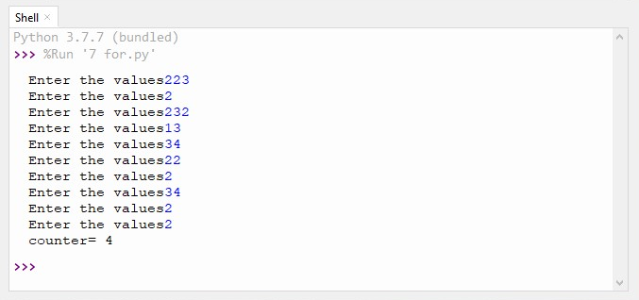

**With while loop:**

**Code:**

counter=0

x=0

while x<10:

a=int(input("Enter a Value"))

if a==2:

counter=counter+1

x=x+1

print("Counter=",counter)

**Output:**

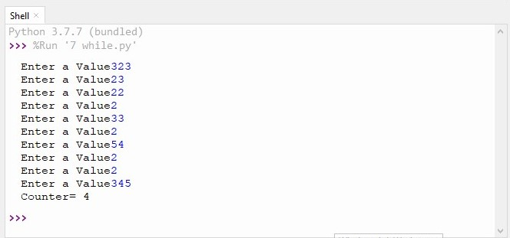

**Task 2:**

Implement a program that prints multiples of 5 in the range defined by user such that only 5  
numbers are printed on one row. Implement using both *while* and *for* loops.

**With for Loop:**

**Code:**

a=int(input("start value"))

b=int(input("end value"))

count=0

i=a

for i in range(a,b):

if i%5==0:

print(i,end='\t')

count=count+1

if count==5:

count=0

print("\n")

**Output:**

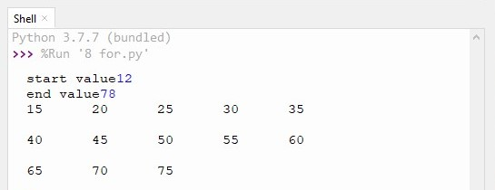

**With while loop:**

**Code:**

a=int(input("start value"))

b=int(input("end value"))

count=0

i=a

while i<b:

if i%5==0:

print(i,end="\t")

count=count+1

if count==5:

count=0

print("\n")

i=i+1

**Output:**

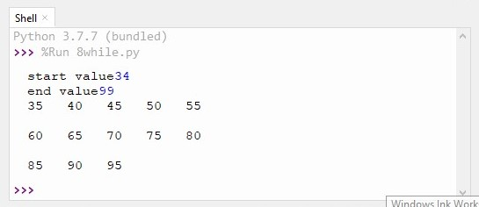

**Task 3:**

Take a number from the user and print its factorial. Implement using both *while* and *for* loops.

**With for Loop:**

**Code:**

x=int(input("Enter the Number"))

factorial=1

if x<0:

print("The factorial of negative integer does not exist")

if x==0:

print("The factorial of 0 is=",1)

else:

for x in range(1,x+1):

factorial=factorial*x

print("factorial of given number=",factorial)

**Output:**

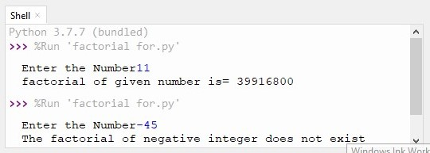

**With while loop:**

**Code:**

x=int(input("Enter the Number"))

factorial=1

if x<0:

print("The factorial of negative integer does not exist")

if x==0:

print("The factorial of 0 is=",1)

else:

while x>0:

factorial=factorial*x

x=x-1

print("factorial of given number is=",factorial)

**Output:**

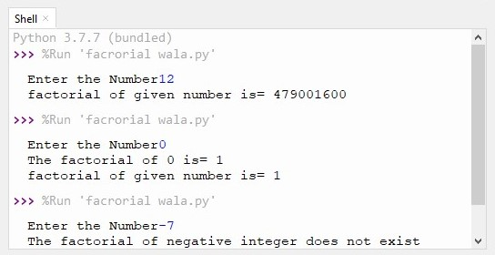

**Conclusion:**

Today I learn how to write a program that prompts the user to enter 10 integers. The program will count the number of times the user enters the integer ‘2’. The count will be displayed on the output screen, write a program that prints multiples of 5 in the range defined by user such that only 5 numbers are printed on one row. And write a program that determine the factorial of given number.